**MODEREN WORK OPPERTUNITY**

**Design Document**

**Version 1.0**



**Group Id :**

**Supervisor Name :**

**Revision History**

|  |  |  |  |
| --- | --- | --- | --- |
| **Date (dd/mm/yyyy)** | **Version** | **Description** | **Tested By** |
| **9/9/2023** | **1.0** |  |  |
|  |  |  |  |
|  |  |  |  |
|  |  |  |  |

**Table of Contents**

1. Introduction of Design Document
2. Entity Relationship Diagram (ERD)
3. Sequence Diagrams
4. Architecture Design Diagram
5. Class Diagram
6. Database Design
7. Interface Design
8. Test Cases

1. Introduction of Design Document

The Design Document maps the requirements into architecture-independent of how these requirements will be accomplished. The architecture defines the components, their interfaces, and behaviors. In the Design Phase, we transform the requirements gathered during the Analysis Phase into a Design Document that accurately describes the design of the system.

The purpose of the Design Phase is to transform the requirements into complete and detailed system design specifications once the design is approved the Design Document will serve as input to the Development Phase. Tools and techniques used in this phase are listed below:

* ER Diagram
* Sequence Diagram
* Architecture Design Diagram
* Class Diagram
* Database Design
* Interface Design
* Test Cases

1. 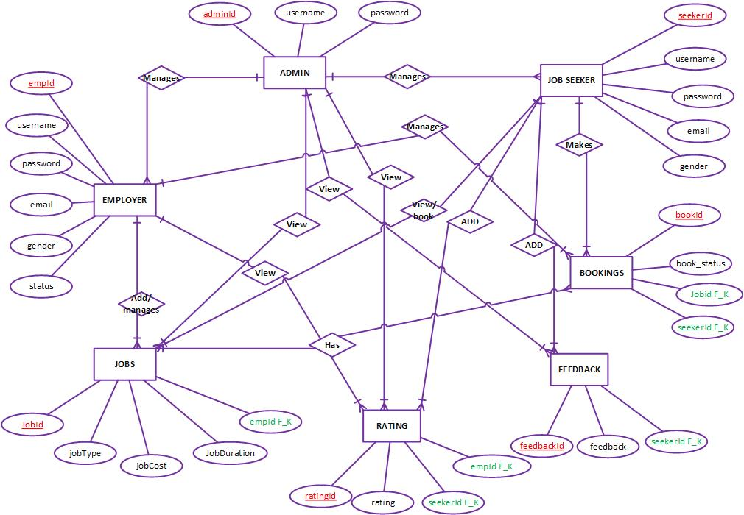Entity Relationship Diagram (ERD)
2. Sequence Diagrams

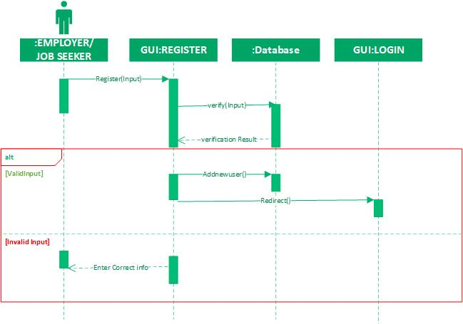**REGISTER**

**LOGIN**

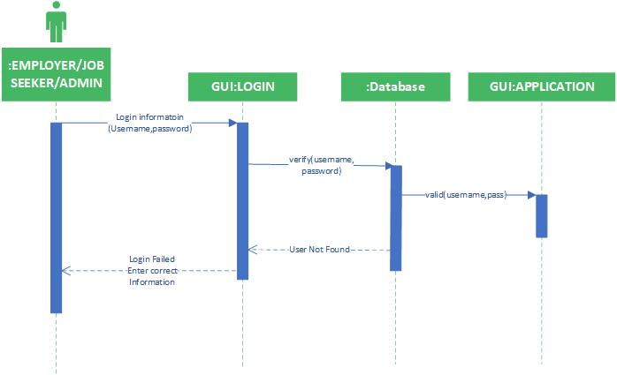

**ADD COMPANY:**

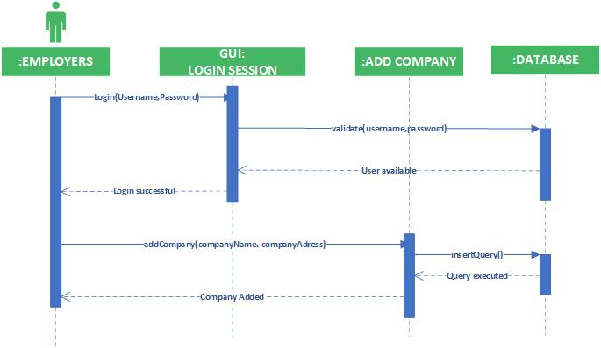

**ADD FEEDBACK**

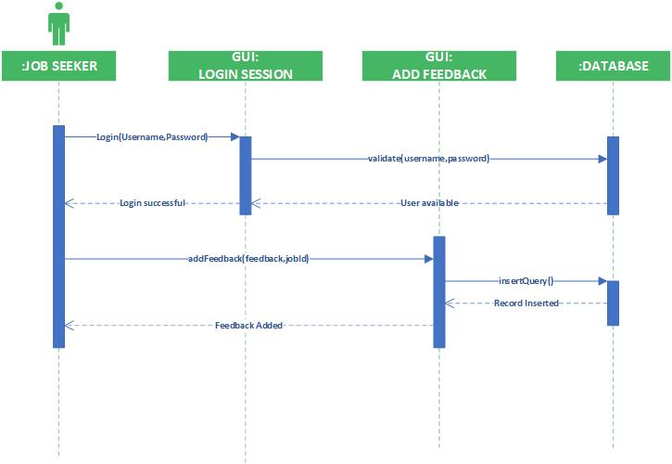

**ADD JOB**

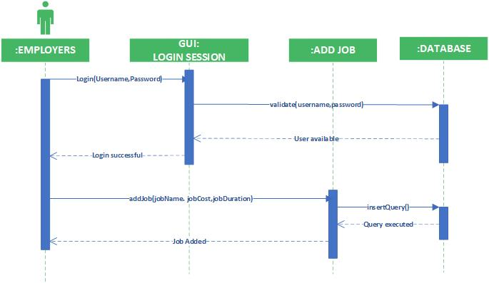

**ADD PROFILE:**

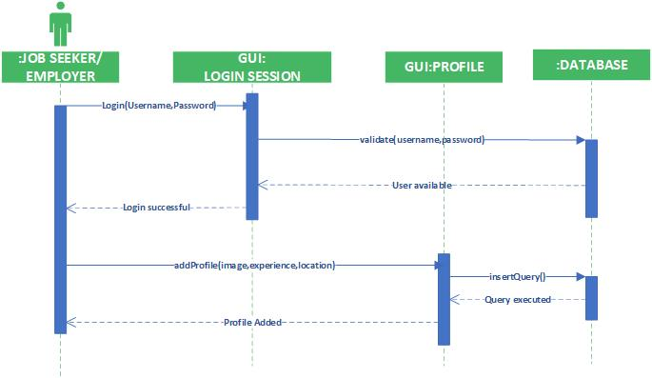

**ADD RATING:**

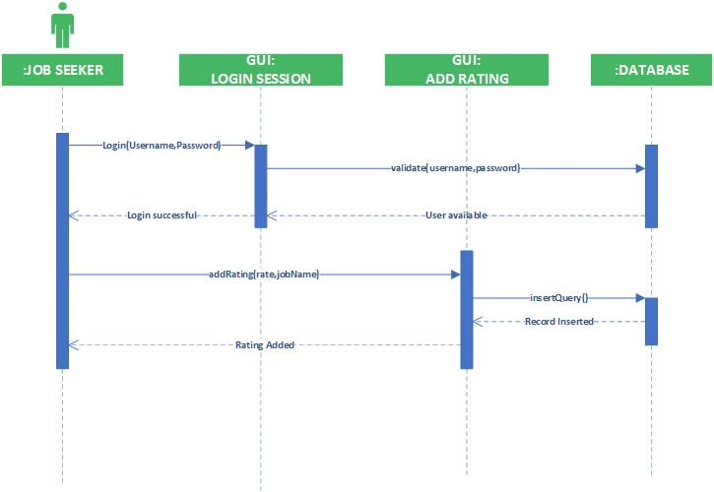

**MANAGE JOBS**

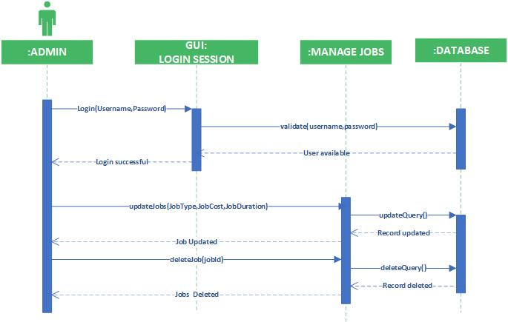

**MANAGE USERS:**

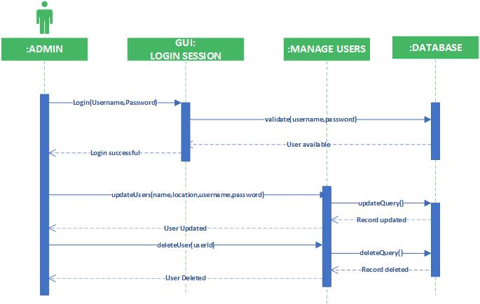

**SEARCH JOB**

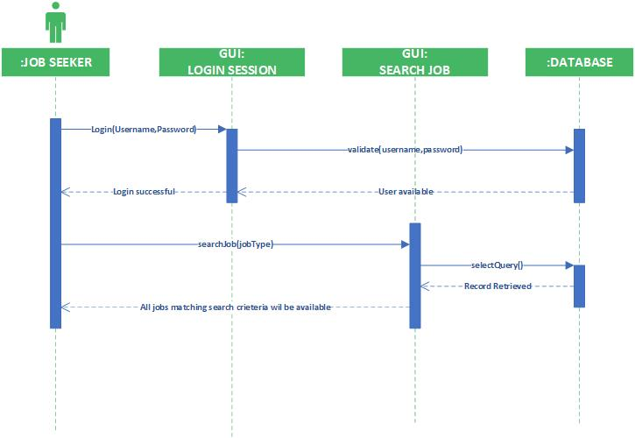

**VIEW RATING**

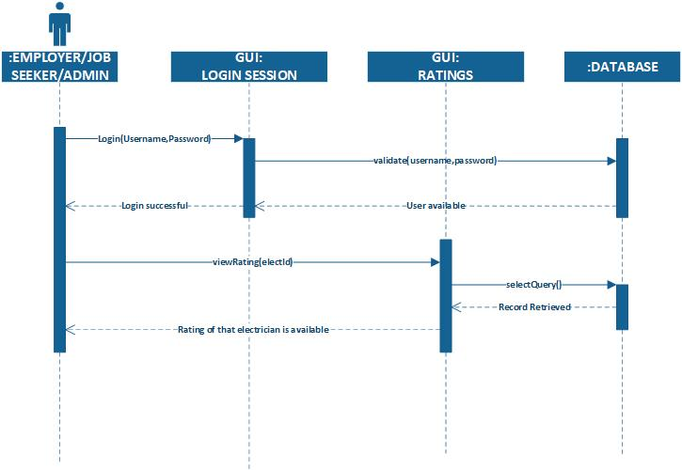

**LOGOUT:**

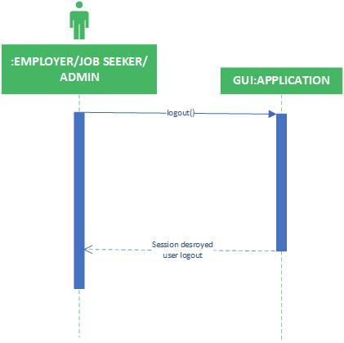

1. 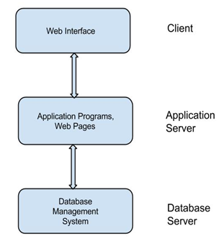Architecture Design Diagram
2. Class Diagram

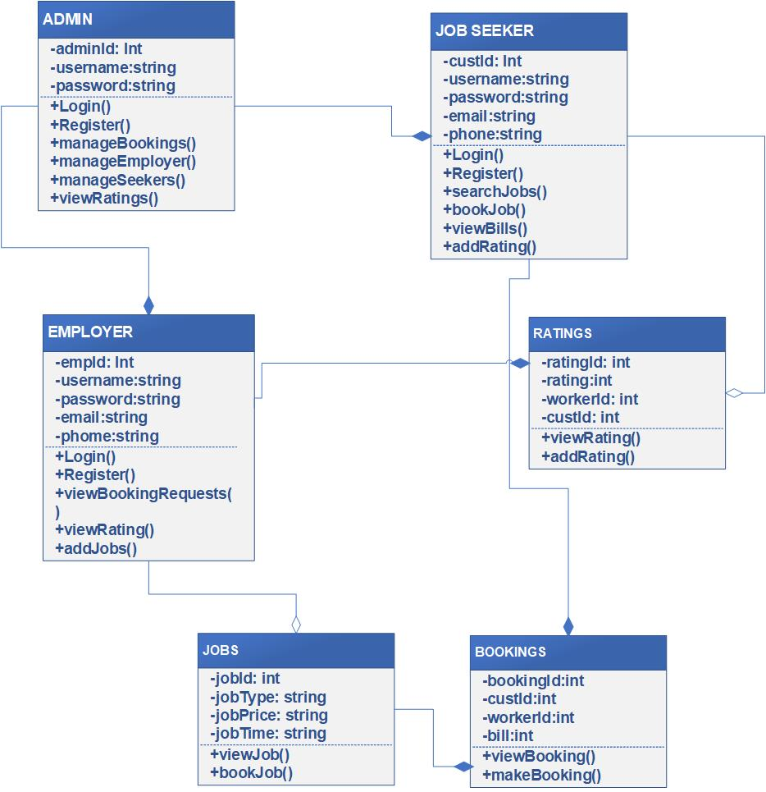

1. Database Design

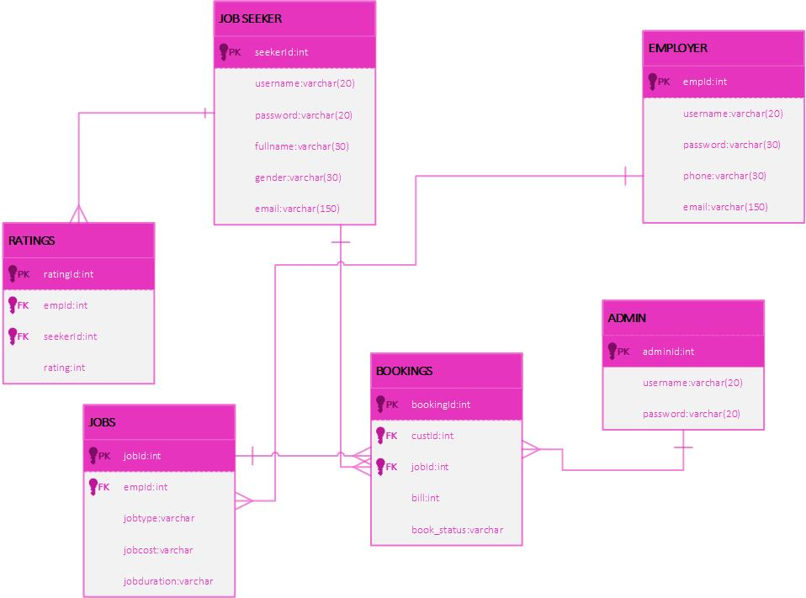

1. Interface Design

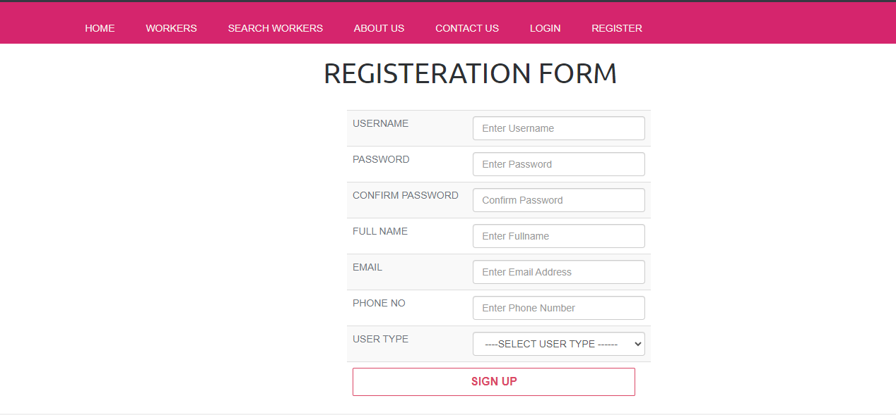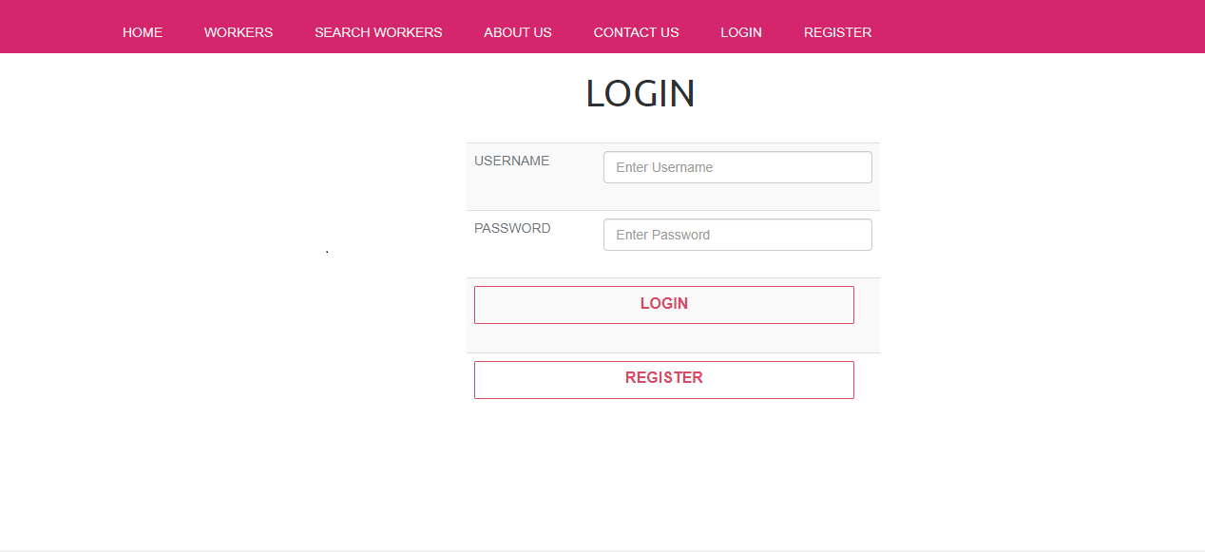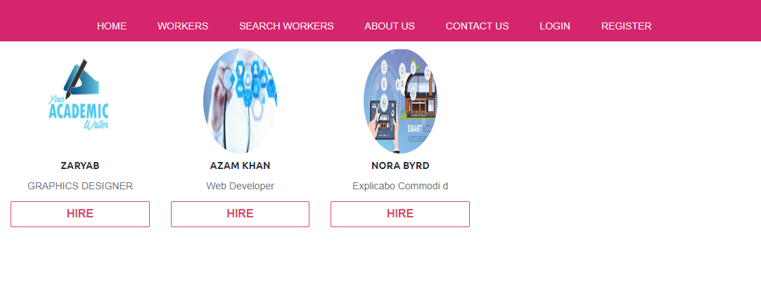

1. Test Cases
2. **Test case 01 Title= Register**

**REGISTER:**

|  |  |
| --- | --- |
| Pre-condition | Application interface must be available. |
| Action | 1. Open application interface of create account 2. Fill the form of registration 3. Click on “Register” button to get registered |
| Expected Results | Employers/Job Seeker successfully created in database. |
| Results | Pass |
| Tested By |  |

**LOGIN:**

|  |  |
| --- | --- |
| Pre-condition | Actors must be registered with our website , Application interface must be available |
| Action | 1. Open application interface of login 2. Enter user name and Resultsword 3. Click on “Login” button |
| Expected Results | Actors successfully login and able to further work |
| Results | Pass |
| Tested By |  |

**ADD PROFILE:**

|  |  |
| --- | --- |
| Pre-condition | Employer user of the system must be registered with our website and logged in. |
| Action | 1. Login as Employer 2. Fill add profile form 3. Click on “Update Profile” button |
| Expected Results | Profile successfully updated and available to job seekers and employers and vice versa |
| Results | Pass |
| Tested By |  |

**ADD JOB:**

|  |  |
| --- | --- |
| Pre-condition | Pass user of the system must be registered with our website and logged in. |
| Action | 1. Login as Passs 2. Fill add room form 3. Click on “Add Job” button |
| Expected Results | Job successfully added and available on our website for job seekers. |
| Results | Pass |
| Tested By |  |

**ADD COMPANY:**

|  |  |
| --- | --- |
| Pre-condition | Application interface must be available. And system must be logged in as Employer |
| Action | 1. Open application interface of create account 2. Fill the form of add company 3. Click on “Add Company” button to get registered |
| Expected Results | Company successfully created in database. |
| Results | Pass |
| Tested By |  |

**MANAGE USERS:**

|  |  |
| --- | --- |
| Pre-condition | Application interface must be available. And system must be logged in as Admin |
| Action | 1. Open application interface of create account 2. View manage_user.php page 3. Select Particular user to manage 4. Perform your desired actions |
| Expected Results | Upated information added in database. |
| Results | Pass |
| Tested By |  |

**GENERATE REPORTS:**

|  |  |
| --- | --- |
| Pre-condition | Application interface must be available. And system must be logged in as Admin |
| Action | 1. Open application interface of create account 2. Click on “View Reports” button 3. Select Your desired report i.e monthly daily etc |
| Expected Results | Employee successfully created in database. |
| Results | Pass |
| Tested By |  |

**MANAGE JOB:**

|  |  |
| --- | --- |
| Pre-condition | Application interface must be available. And system must be logged in as Pass |
| Action | 1. Open application interface of create account 2. View manage_jobs.php page 3. Select Particular Job to manage 4. Perform your desired actions |
| Expected Results | Upated information added in database. |
| Results | Pass |
| Tested By |  |

**ADD FEEDBACK:**

|  |  |
| --- | --- |
| Pre-condition | Application interface must be available. And system must be logged in as Job Seeker |
| Action | 1. Open application interface and select particular employer 2. Fill Add Feedback Form 3. Submit your feedback |
| Expected Results | Feedback submitted and send to that particular Employer |
| Results | Pass |
| Tested By |  |

**SEARCH JOB:**

|  |  |
| --- | --- |
| Pre-condition | Application interface must be available |
| Action | 1. Open application interface and fill the criteria of search job. 2. Click on the “SEARCH” button |
| Expected Results | All jobs that fall on the search criteria will be displayed on the website |
| Results | Pass |
| Tested By |  |

**ADD RATING:**

|  |  |
| --- | --- |
| Pre-condition | Application interface must be available. And system must be logged in as Job Seeker |
| Action | 1. Open application interface and select particular employer 2. Give Rating Through Star rating 3. Submit your Rating |
| Expected Results | Rating submitted and send to that particular Employer |
| Results | Pass |
| Tested By |  |

**LOGOUT**

|  |  |
| --- | --- |
| Pre-condition | The application interface must be available and any of the actor must be Logged in. |
| Action | 1. Open application interface. 2. Click on Logout Button. |
| Expected Results | Session is destroyed and actor will be logout from system. |
| Results | Pass |
| Tested By |  |